Revision

Can you please add site lock logo on the top right of my home page and privacy policy to the bottom of my website. These were purchased but unable to add them to my website.

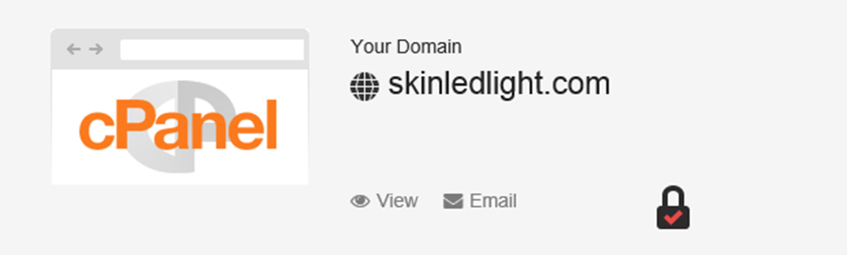



When I go choose the led light (RED, BLUE and Yellow , I notice the information about the LED Light is on the far right. Can it be center just below the LED light images? Also regards to the LED light Images, can you make them a bit smaller.

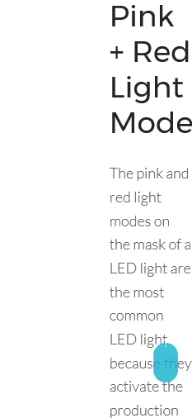

Regards to the products associated with the LED light (red, blue, yellow), can you add something to compel the visitor to buy now. Maybe a large ‘buy now box” above the products

Finally can you eliminate the white light therapy

